Parys Technografx Ltd

PT Pocket Office Manual

Installing PTeSVNC

Installing PTeSVNC

(You can connect PT Pocket Office to other versions of VNC instead, enabling you to use PT Pocket Office with OSX or Linux etc. as well as Windows)

PTeSVNC is Parys Technografx’ VNC server and client software for Windows.
The installer file is “SetUpPTeSVNC.exe”.

To install PTeSVNC on your PC you need to run “SetUpPTeSVNC.exe”, the installer will install PTeSVNC to a destination of your choice.

Once installed, in order to connect from your WM5 device you must have PT Pocket Office installed on your WM5 device, run the PTeSVNC WinVNC server program with a valid TCP/IP connection (e.g. WiFi, Bluetooth or via the Internet) available from your WM5 device to your PC and then run PT Pocket Office on your WM5 device.

PT Pocket Office is compatible with versions of UltraVNC, RealVNC, TightVNC, eSVNC, OSXvnc etc.

Note that when you first run WinVNC on your PC you should supply a suitable password to allow client software (such as PT Pocket Office) to connect to your PC.

On some systems you may need to go into the advanced options in WinVNC and enable loopback connections in order to connect to PT Pocket Office (try this if you’re sure you’re using the correct password but PT Pocket Office returns "authentication failed" when trying to connect – note that another reason for authentication failure is when connecting to a RealVNC v4.x server in which case you need to set the server options to “Legacy” RFB 3.3 mode).

If connecting to RealVNC 4.x then you must go into the VNC server “Legacy” options and enable RFB 3.3 mode. If connecting to a VNC server that does not support compatible server-scaling then PT Pocket Office will automatically connect with server scaling turned off.
Also if connecting to versions of RealVNC then the “Tight” encoding will be ignored by the VNC server and the next best option used instead e.g. “Hextile” in the case of RealVNC.

If you wish to use ports other than 5900 to 5909 you will have to use a VNC server other than PTeSVNC - e.g. UltraVNC. Note that on some phone contracts use of ports is very restricted and port 5900 may not be available for use. Check with your network operator if you have problems connecting e.g. on some T-mobile contracts in the US you may need to use port 25.
WinVNC

WinVNC is VNC server software for the PC. It allows compatible VNC client software to connect to, view and control your PC when it is running.
When you first run WinVNC you need to supply a password that will be required from any VNC client software trying to connect to your machine. Note that to connect PT Pocket Office to a RealVNC 4.x server requires the server “Legacy” option set to use RFB 3.3 mode
The configuration menu that appears when you first run the program (below) can also be accessed any time WinVNC is running by either right-clicking on the WinVNC icon on your taskbar and selecting Properties, or by selecting Programs -> PTeSVNC -> Server -> WinVNC User Settings from your Start menu.

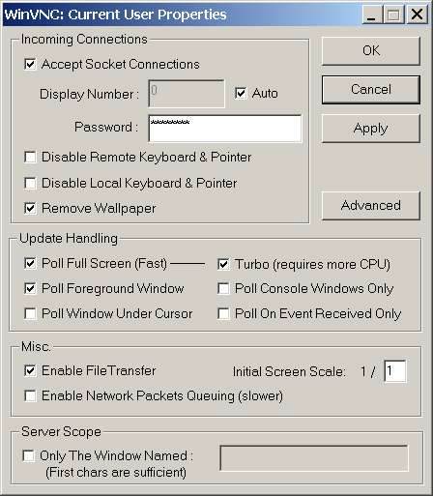
The important things to note are that you can set WinVNC to allow a client to connect and view your PC whilst not allowing remote control of your PC’s mouse and keyboard. You may also disable the PC’s own mouse and keyboard allowing only remote control. The remove wallpaper option will do exactly that when any connection is made, this makes transfer much faster when the PC’s desktop is in view. It is recommended that the “Update Handling” options are set as indicated to the left. However it’s worth noting that “Poll Console Windows Only” will only allow sending of standard windows and dialogs (something which will usually be sufficient for most users and in such cases may improve performance).
Note that you may also disable File Transfer by unticking “Enable File Transfer”.
On some systems “Enable loopback” may need to be selected in the ‘Advanced’ section to connect to PT Pocket Office. Another feature in the Advanced section allows you to enable logging of activity – this could be useful for troubleshooting any problems.
To close WinVNC when it’s running right-click on the WinVNC icon on your taskbar and select close from the menu (you can also change the settings this way).
You may set up WinVNC as a service, this will start WinVNC each time you boot your PC. To set WinVNC as a service go to Programs -> PTeSVNC -> Server -> Install WinVNC Service from your Start menu (the remove service is here also). Reboot your PC after installation and then set the WinVNC password/ports etc.
In the advanced options there is an option to lock your PC when a client disconnects.
If a PC is locked then you will only be able to reconnect if WinVNC is running as a service, you cannot connect to a machine that is waiting for initial logon after a cold boot. Note also that a Control-Alt-Delete key combination sent from the client program will only affect the PC if WinVNC is installed as a service.

VNCviewer

The VNCviewer provided with PTeSVNC is the VNCviewer from eSVNC 112r2.
VNCviewer is VNC client software for the PC that allows a remote PC to connect/control another PC running the PTeSVNC WinVNC server.

As with PT Pocket Office you can control your connection settings from the options in VNCviewer:

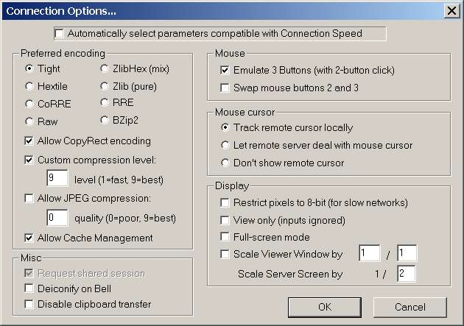
Note that in order to configure your settings manually you must first disable “Automatically select parameters compatible with Connection Speed” as in the graphic.
See the section about PT Pocket Office for more help regarding the connection settings.
Note also that in the VNCviewer once you have made changes you may need to select “Request screen refresh” from the menu for changes to become apparent

Installing PT Pocket Office

PT Pocket Office is Parys Technografx’ VNC client software for the Windows Mobile 5 devices. The Windows installer file is “InstallPTPocketOfficePPC.exe” for devices with touchscreens or “InstallPTPocketOfficeSP.exe” for devices without.

To install PT Pocket Office to your WM5 device you need to connect your WM5 device to your PC via ActiveSync and then run “InstallPTPocketOfficePPC.exe” or “InstallPTPocketOfficeSP.exe” on your PC.
If you are unable to do this as you only have an OSX or Linux system etc. then simply copy the appropriate PT Pocket Office CAB file from the original PT Pocket Office zip file (or CD) into Windows\Start Menu\ on your WM5 device then run the CAB file on your device to install PT Pocket Office.

After retrieving information from your WM5 device the installer will allow you the option of installing to the default download location (Program Files in your normal WM5 device memory) or to select an alternative location e.g. a storage card or other directory.

Simply follow the instructions on PC and WM5 device to install.

Once installed, in order to connect to your PC you must have PTeSVNC (or other VNC software) installed on your PC, have the VNC server program (e.g. WinVNC) running and ready to accept connections, and of course a valid UDP/TCP connection available from your WM5 device to your PC.

Note that to connect over Bluetooth or over USB, then ActiveSync must be running over the connection for the VNC connection to be made - this is not required over GPRS/CDMA or Wi-Fi.

NB. PT Pocket Office will now connect successfully to versions of eSVNC, PTeSVNC, UltraVNC, RealVNC, TightVNC and OSXvnc. Note that for VNC servers that do not have compatible server scaling (e.g. RealVNC or TightVNC) then PT Pocket Office will automatically turn server scaling off. If connecting to a RealVNC v4.x server then you must set the “Legacy” option to use RFB 3.3 mode.
Also if connecting to WinVNC servers that do not support the “Tight” encoding (e.g. RealVNC) (or the currently selected encoding) then for optimum performance PT Pocket Office will automatically choose the best of the encodings that are compatible with the VNC server.

To uninstall PT Pocket Office from your Pocket PC the best way is to re-run the installer program on your PC, select “no” when asked if you wish to install then select PT Pocket Office from the list of installed software and select “remove”.

First run of PT Pocket Office

The very first time you run PT Pocket Office the first screen that appears allows you to set up the orientation of the display and the joypad and the second screen lets you define the main control buttons for PT Pocket Office.

The first screen appears as below:

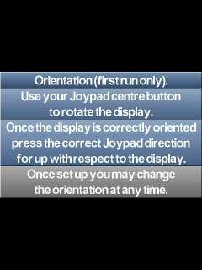

Once you’ve set the orientation as instructed the next screen allows you to define the main control buttons:

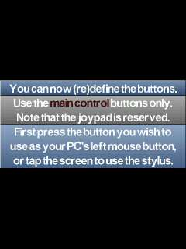

One button is required as your server’s left mouse button, one as the server’s right mouse button, one as PT Pocket Office “options” and one for “quit program”.
The recommended button combination is left menu button (or stylus) as the server’s left mouse button, right menu button (or stylus) as the server’s right mouse button, “make call” (or left menu button) for “options” and “end call” (or right menu button) for “quit program” but other combinations are possible.
When connected and viewing the Options Menu then pressing the “options” button a second time will bring up the Connection Options Menu.
When connected and viewing the Connection Options Menu or the Connection Statistics then pressing the “options” button will remove the menu.
Once the buttons are defined you can press and hold the “options” button to bring up the in-program help.

The above screens will only appear at the start on the very first run of PT Pocket Office however you will always have the option of re-orienting or redefining the buttons if you need to do so. This can be done by selecting “Redefine Buttons” or “Orient Joypad” from the Options Menu whilst connected.

Connecting PT Pocket Office to PTeSVNC

First of all a server (e.g. WinVNC from PTeSVNC) needs to be installed and running on your PC (see above) and you must have a valid TCP/IP connection from your PC to your WM5 device (this could be Wi-Fi, Bluetooth or a remote internet connection).
Secondly you need to know either the network name of the server PC or its IP address. The connection password of the VNC server is also required.
Now you can run PT Pocket Office, select remote or local, enter the host (server) name or IP address and then the password to connect to the VNC server.
Once connected you will view some or all of your PC’s screen on your WM5 device and (optionally in the VNC server) have control over the PC’s mouse and keyboard from your WM5 device plus (optionally) be able to transfer files between PC and WM5 device.

Entering the host (server) name/IP (and optional port)

When you run PT Pocket Office normally the first screen is for entry of the host name or IP address e.g. “office” or “192.168.0.1”. If you wish you can specify a display/port as well e.g. “office:1” or “192.168.0.1:80”, although it is recommended that the default port 5900 is used (no specification needed). To type in the text tap your stylus on the graphical keyboard (see below) or use your hardware keyboard or keypad as available.
NB. The default port used is 5900, specifying a port number from 0 to 9 will use a port from 5900 to 5909, specifying a port number 10+ will use that exact port number and for remote connection the port used must be available through your router/firewall (and routed correctly if you have a router).
Use the joypad directions to choose local or remote connection (irrelevant without phone hardware) or to change the keyboard input method.
It should be noted that if you opt for a Bluetooth/Wi-Fi connection then any current open connection to GPRS or CDMA (e.g. from when browsing or downloading) will be disconnected.
You can press the “options” button if you wish to choose a previously saved connection (if any are available). On the saved connections screen you can select from the list of connections using either the stylus or the joypad up/down and centre. You can also re-order the connection list using joypad left/right.

Keyboard entry

Changing the keyboard input method will change the screen as below:

“QWERTY Keys” mode is for those with a full qwerty keyboard and you can just use it pretty much as normal.

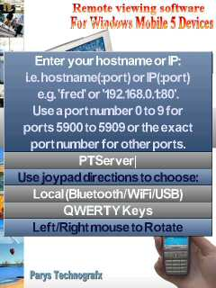

“Q+ or stylus Keys” can be used by anybody. It has three methods of input. First of all Motorola Q users must note the graphical keys map directly to the keys of your hardware keyboard, e.g. your “func” key changes the keyboard layout. Secondly users with a stylus (i.e. who have a PPC) can tap on the graphical keys to enter text (the bottom-left key changes the layout). On any device, pressing the designated “exit program” button once only on the hostname or password screens will display a cursor on the keyboard enabling users to enter text via the joypad directions and left mouse button. The bottom-left key changes the characters available and cursor-entry mode can be exited by using the left mouse button to press the key for tab. When connected cursor-entry mode is always available for “Q+ or stylus Keys”. Note that special keys like Shift, Control, Alt etc. stay pressed until pressed again.

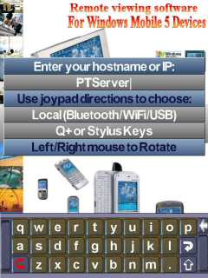

“Smartphone Keypad” mode is used for users wishing to use the standard Smartphone text entry method. This is designed for use on devices without a stylus (this mode is not designed for use with the Motorola Q). It functions much as normal multi-press keypad entry does, press and hold your “*” button to change the layout, press and hold “#” for symbols (press backspace to exit symbol entry mode if you decide you don’t want a symbol after all).

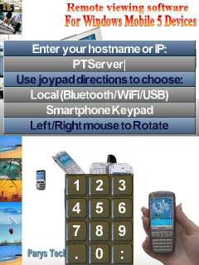

“Smartphone Keypad+” is similar to the “Smartphone Keypad”, but provides the extra functionality of a PC keyboard (Shift, Control, Function Keys, etc). Unlike the “Smartphone Keypad” mode it doesn’t use the multi-press method, instead use “*” and “#” on your keypad to change the layout. Use the “home” button for Left Shift. Note that Shift, Control etc. stay pressed until pressed again.

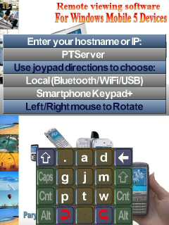

Note that joypad centre is also used as the “Enter” (return) key in all entry modes.
The method of keyboard entry can be changed at any time.

Entering the password

When you’ve entered the host (:port) and the host given is found then the password entry screen will appear for you to give the appropriate password for the VNC server:

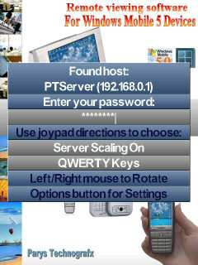

If (as in the example) a host name is used rather than an IP address then the IP address found for the given name is displayed on the password screen (this gives you some idea whether your router located the correct machine or not).
If you wish to return to the hostname entry screen you can do so by pressing your “home” button if you have one and are not in “Smartphone Keypad+” mode. This can also be done by pressing the “Esc” key in “Q+ or stylus” mode or by pressing backspace when the password is blank (in any keyboard entry mode).
You can use the joypad directions to choose whether to enable/disable server scaling or to change the keyboard entry method.
Note that some versions of WinVNC (eg. RealVNC or TightVNC) do not support server-scaling and when connecting to these server scaling will automatically be set to “off”.

On the password entry screen you can press the “Options” button to change the initial connection settings:

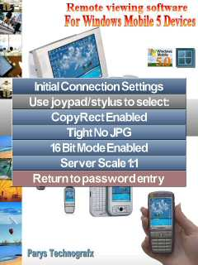

Use the joypad directions and joypad centre or the stylus to change the connection settings.
See the section on “Connection Options” for more details of the available connection settings.

After entering the password the following screens should appear:



After a few seconds connection should be made and some or all of your PC’s screen will appear on your device:

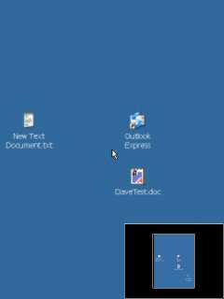

If it takes longer than a minute or so for this to happen using Bluetooth or Wi-Fi, or longer than 2 or 3 minutes using GPRS or CDMA then press the backspace button or tap the screen with the stylus to go back and make sure you got the host(:port) and password correct. If connecting to RealVNC v4.x and you get an authentication error then check that the “Legacy” option in the RealVNC server is set to use RFB 3.3 mode.
If you’re sure you have the host(:port) and password correct and have repeated the procedure two or three times without success, then exit PT Pocket Office and re-run it to try again. Obviously when wanting a remote connection on a phone device via GPRS or CDMA you must have GPRS or CDMA available with a (preferably good) signal.
Please note that VNC servers from some versions of VNC are not compatible with PT Pocket Office so if you have tried everything suggested in this help file (see the support section at the end) and are still unable to connect then try using a different VNC server (such as PTeSVNC or UltraVNC) instead of the version you are currently using.
PT Pocket Office has been tested successfully with the following servers:

UltraVNC v1.02 (recommended), v1.01, v1.0.0 rc11d,
RealVNC v4.x (in ‘Legacy’ RFB 3.3 mode), v3.x,
TightVNC v1.3.8, v1.2.9,
PTeSVNC (included).

It will also work with other versions of the above and other versions of VNC such as OSXvnc.
File Transfer is currently available when using a PTeSVNC or UltraVNC server.

The Options Menu

Once connected when you press the “options” button the Options Menu will appear:

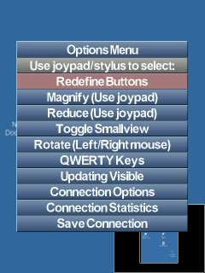

Use either the joypad or the stylus to use the Menu.
When using the joypad use up/down to select an option and left/right/centre to execute/change the option.
When using the stylus to select an option tap it once and it will be highlighted in red as above then tap the option a second time to execute/change the option.

“Redefine buttons” allows you to do exactly that.
“Magnify” allows you to use the joypad to control the viewing magnification.
“Reduce” allows you to use the joypad to control the viewing reduction.
“Toggle Smallview” turns the small full-screen viewing window on and off.
“Rotate” rotates the view (for left/right handed users and to switch between portrait and landscape). When rotate is selected use your left and right mouse buttons to rotate. “Rotate screen” can be changed to “Orient Joypad” by using left/right joypad if you need to orient your joypad – in this case press joypad centre then press the correct joypad direction for up with respect to the display.
“QWERTY Keys”/”Q+ or Stylus Keys”/”Smartphone Keypad”/”Smartphone Keypad+” allow you to choose the character input method.
“Updating All/Visible (refresh)” allows you to choose whether changes to areas of your PC screen not currently in view are updated immediately or not and to force a refresh of the display if needed. When using Updating Visible changes will only be updated in the visible area, this can save a lot of bandwidth. Note however that when scrolling around using Updating Visible there may be a slight delay before the view is updated. Also remember that sometimes a dialog box may appear on the server system that is outside the current viewing area. If you seem to get a permanent error on the display then you can highlight this option then press joypad centre to force a screen refresh.
“Connection Options” takes you to the Connection Options menu.
“Connection Statistics” displays your connection statistics (bytes sent/received).
Save Connection allows you to save the current connection (hostname and all settings) with a chosen name for ease of future connection. You could call the connection “Work:BT” or “Home:GPRS” etc. Saved connections can be recalled from the hostname entry screen by pressing the “options” button next time you are making a new connection.
It’s worth noting that if the Options Menu is displayed then pressing the “options” button will take you directly to the Connection Options Menu.
Connection Options
The Initial Connections Settings (below left) will appear when you press the “options” button on the password entry screen, the full Connection Options Menu (below right) will appear when connected when you either select Connection from the Options Menu or press the Options button while the Options Menu is displayed:

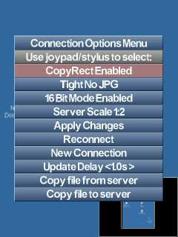
As with the Options Menu the joypad or stylus is used for navigation.
When using the joypad use up/down to select an option and left/right/centre to execute/change the option.
When using the stylus to select an option tap it once and it will be highlighted in red as above then tap the option a second time to execute/change the option.

The first option allows you to enable or disable the “Copy Rect” feature of the transfer encodings, selecting this option will toggle between “Copy Rect Enabled” and “Copy Rect Disabled”. It is recommended that this is enabled, as it can use less bandwidth.
The second option (“Tight” above) is the main transfer encoding method. Selecting it will rotate between:
- Tight (+JPG option)
- Zlib
- Zlib Hextile
- Hextile
- CoRRE
- RRE
- RAW (uncompressed)
Note that only ‘Hextile’, ‘CoRRE’, ‘RRE’ and ‘RAW’ are supported by versions of RealVNC and in this case choosing the other options means WinVNC will automatically choose the best available option i.e. “Hextile”.
It is recommended that ‘Tight’ is selected, further explanation can be found in ‘Encoding/Settings’ section below.
The third option allows you to toggle between ‘8 bit’ RGB and ‘16 bit’ RGB transfer. ‘8 bit’ is up to twice as fast but ‘16 bit’ provides better quality. Note that for the Tight JPG options JPG is only used when using 16 bit transfer.
The fourth option allows you to choose the amount of server scaling to use with compatible VNC servers (UltraVNC or PTeSVNC). 1:1 provides pixel perfect transfer (unless using JPG) but is costly in terms of speed and bandwidth, 1:2 is up to 4* faster and uses up to 4* less bandwidth than 1:1, 1:3 is up to 9* better than 1:1 etc. Note that when connected to a VNC server that does not support server-scaling then changing this option is ignored.
If choosing the ‘Connection Settings’ from the hostname entry screen then simply choose “Return to password entry” when the settings are as you require.
‘Apply Changes’ applies any changes you have made to the settings.
‘Reconnect’ disconnects then reconnects to the current host even if the settings haven’t changed. This option is mainly in case you get a hung connection.
‘New Connection’ disconnects from the current host and lets you select a new host to connect to.
‘Update Delay’ can be used to delay update requests from the server i.e. so PT Pocket Office requests screen updates from the server less often. Changing the seconds to values >0 will cause screen updates from the server to be requested at a maximum one update every x seconds. Higher values will slow response times, however will also help lower bandwidth usage. Simply use joypad left/right to change the refresh value. The default is 1.0 but you may find 0.3 more optimum (values below 0.3 will tend to waste bandwidth).
‘Copy file from server’ will enter file transfer mode to copy a file from the server to the WM5 device when connected to a compatible VNC server.
‘Copy file to server’ will enter file transfer mode to copy a file from the WM5 device to the server when connected to a compatible server.
Press the “options” button to exit the ‘Connection Options’ Menu.

Connection Statistics

When you select ‘Connection Statistics’ from the Options Menu, a screen like the one below will appear:

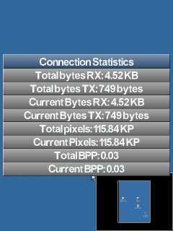

This information is mainly a guide; it does not necessarily give the exact bandwidth use but a reasonable idea.
Note that the “Total” values are those from when you ran the program, no matter how many different connections you have made.
The values for bytes received (RX) and bytes transmitted (TX) include the amounts used for file transfer, however the bytes received figure used internally to calculate the Bytes per pixel does not include bytes received during file transfer hence the Bytes per pixel values give an accurate indication of how good your current Connection Settings are at saving bandwidth (‘Tight’ or ‘Zlib’ seem the best encodings by far from this point of view).
To remove the ‘Connection Statistics’ press the Options button.

Keyboard modes

In each keyboard mode you will see one of the displays below:

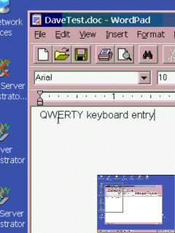
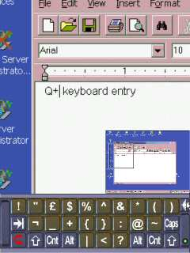
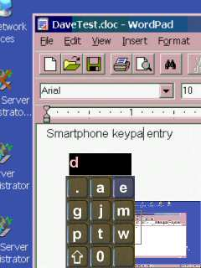
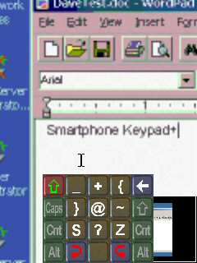
You can change the keyboard entry method at any time from the Options Menu when connected.

Explanation of the various keyboard entry methods can be found in the ‘Keyboard Entry’ section above.

Note that joypad centre is also used as the “Enter” (return) key in all entry modes.
The layouts change appropriately when the virtual keyboard Shift, Caps lock etc. are active.

Magnify/Reduce

The server screen can be viewed magnified from the current transfer size, at the current transfer size or reduced from the current transfer size including being able to see the entire server screen on your WM5 device. When less than 80% of the server screen width/height is visible on your WM5 device a small full-screen view of the server screen will appear in the bottom-right hand corner of the display when “Smallview” is enabled.

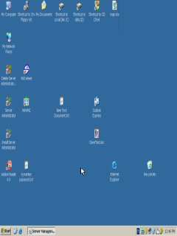
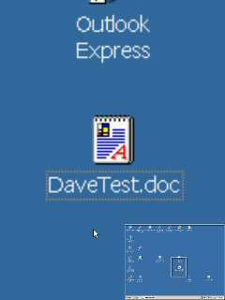
To change the magnification or reduction select “Magnify” or “Reduce” from the Options Menu then use the joypad directions to change the magnification/reduction. Press joypad centre when the display is at the size you wish.

Smallview

The Smallview window showing a full-screen view of your server can be toggled on and off from the Options Menu. Even when “on” it will only appear when less than 80% of the server screen’s height or width is visible.
When the Smallview window is visible you can press the left mouse button on it to go quickly to any location on your server screen. You can also drag the smallview window to alternate locations on your display – for example if you need to see the bottom-right corner of your server’s screen. To do this using a stylus simply tap, hold and drag. To do it using buttons, when the cursor is over the smallview window press joypad centre then move the window around using the joypad directions then press joypad centre again.

File Transfer

From the Connection menu you can opt to copy a file to or from the server when the server has compatible file transfer enabled.
Transferring a file is the same in either direction.
If you select “Copy file from server” then you will first see a screen like this:

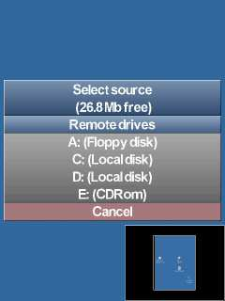

As you can see it will show the available drives on your PC. To choose a drive use the joypad or stylus to select it and you will then view a directory of the drive:
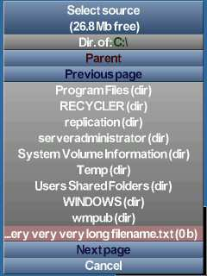

You can now browse to find the file you are looking for.
Selecting a folder (dir) will take you to that folder’s directory, selecting a file will take you to the next stage of file transfer.
As you can see you can go back to parent and possibly to next page and previous page.
Once you’ve selected a file you’ll now be able to browse for a destination:
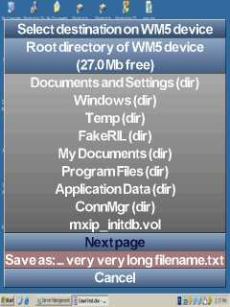

Browse in the same way until you have the required target, don’t worry if you wish to edit the destination filename, you can do that at the next stage.
Select “Save as” to proceed to the filename edit stage:
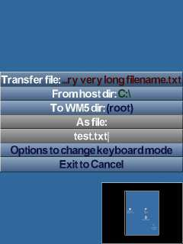

Use the keyboard to edit/enter the filename, the “exit program” button cancels file transfer.
If a file of the selected name & location exists already, you will get the following:
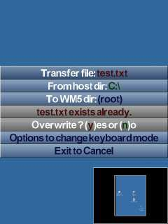

Enter “y” to overwrite the file, “n” to change the filename, the “exit program” button cancels file transfer.
When you have entered the destination filename, file transfer will begin:
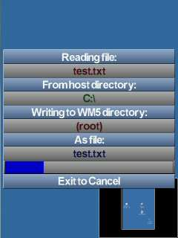

During file transfer you can abort by pressing the “exit program” button once.
When transfer is complete or has been cancelled press “exit program” once to exit file transfer.

Save Connection

When you select the save connection option a screen will appear as below:
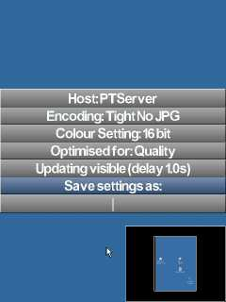
Note that you can use the joypad directions to change the keyboard entry method.
When you enter the name for your saved connection you will be presented with the option to include the (encrypted) VNC password with the data:
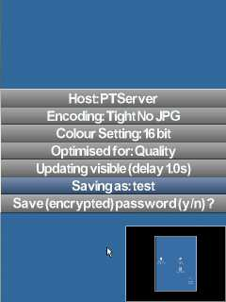
Simply press “y” for yes, “n” for no.

Saved connections can be selected/restored next time you are making a new connection by pressing the “options” button on the hostname entry screen.

Encodings/Settings

To reduce the bandwidth used, i.e. to reduce the amount of, and time taken for, data transfer, PT Pocket Office has several encoding options available:
- Tight(+JPG)
- Zlib
- Zlib Hextile
- Hextile
- CoRRE
- RRE
- Raw
The best option in terms of bandwidth is ‘Tight’ and the worst is ‘RAW’, however the best option in terms of server (PC) overhead is ‘RAW’ and the worst is ‘Tight’ (tests indicate ‘Tight’ and ‘Zlib’ to be almost equivalent except when in ‘16-bit’ mode the higher JPG compression options in Tight reduce bandwidth noticeably). If connecting to versions of RealVNC then ‘Tight’, ‘Zlib’ and ‘Zlib Hextile’ encodings are not supported so the optimum option when considering bandwidth is ‘Hextile’ in this case (which will automatically be selected if you choose an encoding not supported by RealVNC).
Also to reduce bandwidth usage you can opt for using ‘8-bit’ RGB mode, however this may result in some colour banding. It is worth noting however that ‘16-bit’ using ‘Tight + JPG low quality’ uses roughly the same bandwidth as ‘8-bit’ with ‘Tight’ and may be preferable.
PT Pocket Office also allows you to set the amount of server scaling (resizing of the screen) to be used before data transfer (with compatible WinVNC servers).
Note that the screen buffer in PT Pocket Office is 1600x1200 pixels (eg. 1600x1200 or 1200x1600) so when the WinVNC server does not support server scaling server screens larger than this cannot be handled by PT Pocket Office (e.g. 2048x1536) – if using server-scaling then the server screen size does not present this problem provided you set the server scaling such that the server screen is transferred at less than 1600x1200 pixels.
In terms of speed of transfer, bandwidth reduction, or overhead on the PC it is best to have your PC in a resolution of 640x480 pixels with the scaling set at 1:2.
If you require one of the larger resolutions available on your PC and are having trouble reading the text on your WM5 device, one option is to change your PC settings to use large fonts. Either the PC standard option of 125% or a custom font size larger than this can be used.
Note also that you will find the colour scheme used on your PC will have a direct bearing on the legibility of the PC text on your device – some colour combinations resample far better than others.

On some systems you may need to ‘enable loopback’ in the advanced options of the WinVNC server (a symptom requiring this is "authentication failed" in PT Pocket Office – note that another reason for authentication failure is if trying to connect to a RealVNC v4.x server without having set the server’s “Legacy” option to use RFB 3.3 mode).
If your PC’s network uses a router and you wish to connect to a WinVNC server remotely then you must ensure that the appropriate port (5900 to 5909 or other) is being routed to the local IP address of the PC running WinVNC and that the router firewall is allowing data transfer through that port.
On the PC itself you need to ensure that any software firewall is also allowing data transfer through the appropriate port (5900 to 5909 or other).
If your PC is not on a local LAN then you may need to enable the Microsoft Loopback Adapter:
http://support.microsoft.com/default.aspx?scid=kb;en-us;839013
http://support.microsoft.com/?kbid=236869
http://support.microsoft.com/default.aspx?scid=kb;en-us;842561

At the time of writing you can check your PC is open for connection remotely when running WinVNC (if using a port 5900-5909) by going here:
http://www.gotomyvnc.com/
Alternatively (at the time of writing) you can get your remote IP address here:
http://www.whatismyip.com/
In rare cases your PC’s Internet Service Provider may be blocking some ports. If you think everything is set up correctly on the VNC server end using a port 5900 to 5909 and “gotomyvnc.com” reports no connections open then contact your ISP (for the PC).
Mobile network operators may block certain ports, so if your PC is open but you can’t get PT Pocket Office to connect remotely then check with your network operator:
N.B. There have been some issues regarding T-Mobile (US) restricting the ports available and one available is port 25 so in this case you would need a WinVNC server that allows selection of port 25 for connection (e.g. UltraVNC) and to specify port 25 as the connection port in the hostname entry (in PT Pocket Office).
Remember if connecting locally (e.g. via Bluetooth) rather than remotely then you must use the local IP address of your PC (or the PC’s network name) and not the remote IP address – also note that Bluetooth or USB connection only work via ActiveSync.
If you require technical support for PT Pocket Office go to:
http://parystec.com/Pocket_office.htm
for the latest info, FAQs etc.
or E-mail support@parystec.demon.co.uk
PTvncGPRS is available for older PPC2002/2003 devices.
PTvncS is available for SP2002/2003 devices.
PTvncWM5 is available for PPC2003SE devices
PTvncSWM5 is available for SP2003SE devices.

